**Dokumentasi Spesifikasi API H2H**

**Request**

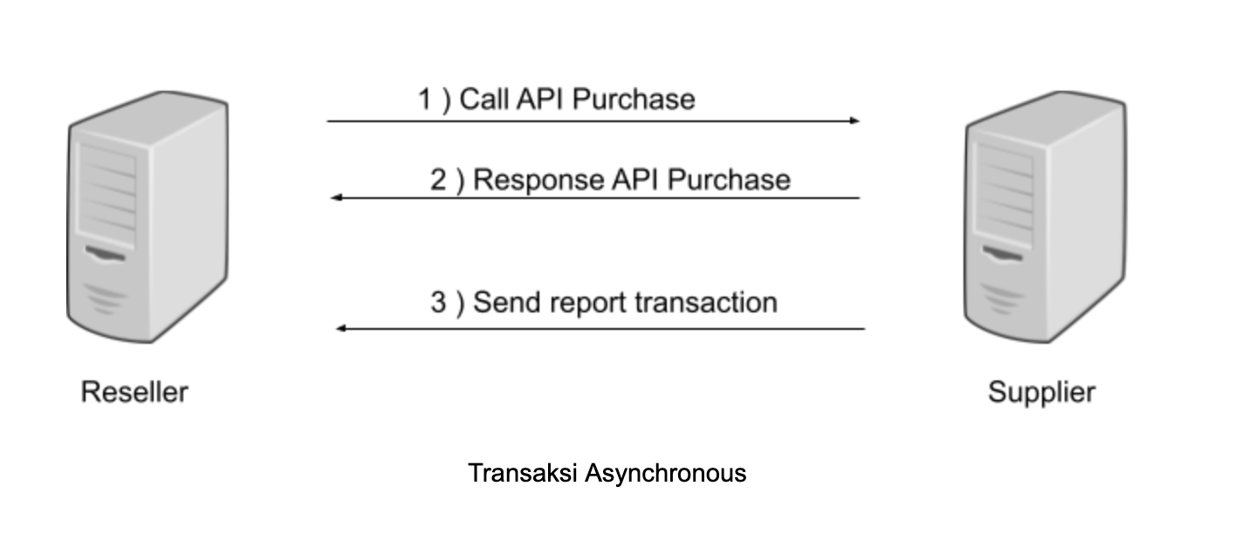

Request transaksi bisa dilakukan dengan IP host to host, pastikan juga anda memiliki IP statis agar bisa kami lakukan whitelist IP. Untuk setiap request akan ditujukan ke alamat dibawah.   
  
Saat melakukan transaksi pembelian, anda akan membutuhkan token authentication. Token bisa anda dapatkan di halaman [Settings](https://niskala.socx.app/#/resellers/settings)  
  
base_url = **https://niskalaapi.socx.app/reseller/api/v1**

**API Check Saldo**

Anda bisa melakukan pengecekan saldo secara realtime dengan memanggil API berikut.

|  |  |
| --- | --- |
| Method | GET |
| URL | {base_url}/saldo |
| Header | Authorization Bearer |

**CURL Request**

curl --location -g --request GET 'https://niskalaapi.socx.app/reseller/api/v1/saldo' --header 'Authorization: Bearer REPLACE-WITH-YOUR-JWT-TOKEN'

**CURL Response**

{

"balance": 14450

}

**API Transaksi HTTP JSON POST**

Anda bisa melakukan hit transaksi dengan menggunakan HTTP JSON POST

|  |  |
| --- | --- |
| Method | POST |
| URL | {base_url}/purchase |
| Header | Authorization Bearer |

**Payload Data**

| **Nama** | **Tipe Data** | **Wajib** |
| --- | --- | --- |
| code | String | Ya |
| msisdn | String (number only) | Ya |
| request_id | String | Ya |

**CURL Request**

curl --location -g --request POST 'https://niskalaapi.socx.app/reseller/api/v1/purchase \

--header 'Authorization: Bearer REPLACE-WITH-YOUR-JWT-TOKEN' \

--header ‘Content-Type: application/json’ \

--data-raw '{

"code":"HSA5",

"msisdn":"08121231231",

"request_id":"999999"

}'

**CURL Response**

{

"code": "HSA5",

"msisdn": "08121231231",

"request_id": "999999",

"rc": "68",

"trxid": 16413,

"price": 5400,

"balance": 341890000,

"sn": "",

"message": "PENDING, Transaksi sedang diproses"

}

**Catatan**

Jika anda melakukan request dengan request_id yang sama dan apabila di server kami request_id tersebut sudah diproses, maka kami akan mengembalikan status response transaksi terhadap request_id tersebut.

**API Transaksi HTTP GET**

Anda bisa melakukan hit transaksi dengan menggunakan HTTP GET

|  |  |
| --- | --- |
| Method | GET |
| URL | {base_url}/http/purchase |

**Payload Data**

| **Nama** | **Tipe Data** | **Wajib** |
| --- | --- | --- |
| code | String | Ya |
| msisdn | String (number only) | Ya |
| request_id | String | Ya |
| token | String | Ya |

**CURL Request**

curl --location -g --request GET 'https://niskalaapi.socx.app/reseller/api/v1/http/purchase?code=HSA5&request_id=123456&msisdn=081234567890&token=REPLACE-WITH-YOUR-JWT-TOKEN'

**CURL Response**

{

"code": "HSA5",

"msisdn": "08121231231",

"request_id": "999999",

"rc": "68",

"trxid": 16413,

"price": 5400,

"balance": 341890000,

"sn": "",

"message": "PENDING, Transaksi sedang diproses"

}

**Catatan**

Jika anda melakukan request dengan request_id yang sama dan apabila di server kami request_id tersebut sudah diproses, maka kami akan mengembalikan status response transaksi terhadap request_id tersebut.

**API Transaksi HTTP POST**

Anda bisa melakukan hit transaksi dengan menggunakan HTTP POST

|  |  |
| --- | --- |
| Method | POST |
| URL | {base_url}/http/purchase |

**Payload Data**

| **Nama** | **Tipe Data** | **Wajib** |
| --- | --- | --- |
| code | String | Ya |
| msisdn | String (number only) | Ya |
| request_id | String | Ya |
| token | String | Ya |

**CURL Request**

curl --location -g --request POST 'https://niskalaapi.socx.app/reseller/api/v1/http/purchase' \

--form 'code="HSA5"' \

--form 'request_id="13013"' \

--form 'msisdn="081471384"' \

--form 'token="REPLACE-WITH-YOUR-JWT-TOKEN"'

**CURL Response**

{

"code": "HSA5",

"msisdn": "08121231231",

"request_id": "999999",

"rc": "68",

"trxid": 16413,

"price": 5400,

"balance": 341890000,

"sn": "",

"message": "PENDING, Transaksi sedang diproses"

}

**Catatan**

Jika anda melakukan request dengan request_id yang sama dan apabila di server kami request_id tersebut sudah diproses, maka kami akan mengembalikan status response transaksi terhadap request_id tersebut.

**API Transaksi XML**

Anda bisa melakukan hit transaksi dengan menggunakan POST XML

|  |  |
| --- | --- |
| Method | POST |
| URL | {base_url}/xml/purchase |

**Topup Request**

<?xml version="1.0"?>

<methodCall>

<methodName>topUpRequest</methodName>

<params>

<param>

<value>

<struct>

<member>

<name>NOHP</name>

<value>

<string>0818111222</string>

</value>

</member>

<member>

<name>REQUESTID</name>

<value>

<string>123456</string>

</value>

</member>

<member>

<name>PIN</name>

<value>

<string></string>

</value>

</member>

<member>

<name>NOM</name>

<value>

<string>HSA5</string>

</value>

</member>

</struct>

</value>

</param>

</params>

</methodCall>

**Topup Response**

<?xml version="1.0" encoding="UTF-8"?>

<methodResponse>

<params>

<param>

<value>

<struct>

<member>

<name>RESPONSECODE</name>

<value>

<string>68</string>

</value>

</member>

<member>

<name>REQUESTID</name>

<value>

<string>123456</string>

</value>

</member>

<member>

<name>MESSAGE</name>

<value>

<string>PENDING, Transaksi sedang diproses</string>

</value>

</member>

<member>

<name>TRANSACTIONID</name>

<value>

<string>5483</string>

</value>

</member>

</struct>

</value>

</param>

</params>

</methodResponse>

**Topup Report XML**

<?xml version="1.0"?>

<methodCall>

<methodName>topUpReport</methodName>

<params>

<param>

<value>

<struct>

<member>

<name>RESPONSECODE</name>

<value>

<string>00</string>

</value>

</member>

<member>

<name>REQUESTID</name>

<value>

<string>12345</string>

</value>

</member>

<member>

<name>MESSAGE</name>

<value>

<string>SUKSES</string>

</value>

</member>

<member>

<name>TRANSACTIONID</name>

<value>

<string>123123</string>

</value>

</member>

<member>

<name>SN</name>

<value>

<string>02123123123123123</string>

</value>

</member>

<member>

<name>MSISDN</name>

<value>

<string>08123123123</string>

</value>

</member>

<member>

<name>PRICE</name>

<value>

<string>5500</string>

</value>

</member>

</struct>

</value>

</param>

</params>

</methodCall>

**API Cek Status**

Anda bisa melakukan pengecekan status dengan hit api berikut

|  |  |
| --- | --- |
| Method | POST |
| URL | {base_url}/status |
| Header | Authorization Bearer |

**Payload Data**

| **Nama** | **Tipe Data** | **Wajib** |
| --- | --- | --- |
| request_id | String | Ya |

**CURL Request**

curl --location -g --request POST 'https://niskalaapi.socx.app/reseller/api/v1/status \

--header 'Authorization: Bearer REPLACE-WITH-YOUR-JWT-TOKEN' \

--header ‘Content-Type: application/json’ \

--data-raw '{

"request_id":"999999"

}'

**CURL Response**

{

"code": "HSA5",

"msisdn": "08121231231",

"request_id": "999999",

"rc": "68",

"trxid": 16413,

"price": 5400,

"balance": 341890000,

"sn": "",

"message": "PENDING, Transaksi sedang diproses"

}

**API Create Tiket Deposit**

Anda bisa melakukan request tiket deposit dengan hit api berikut

|  |  |
| --- | --- |
| Method | POST |
| URL | {base_url}/deposit_ticket |
| Header | Authorization Bearer |

**Payload Data**

| **Nama** | **Tipe Data** | **Wajib** |
| --- | --- | --- |
| amount | Number | Ya |

**CURL Request**

curl --location -g --request POST 'https://niskalaapi.socx.app/reseller/api/v1/deposit_ticket \

--header 'Authorization: Bearer REPLACE-WITH-YOUR-JWT-TOKEN' \

--header ‘Content-Type: application/json’ \

--data-raw '{

"amount":1000000

}'

**CURL Response**

{

"instruction": "Mohon transfer nominal Rp. 1,000,101 (harus sama), ke rekening BCA 1234567890, Mandiri 0987654321 sebelum 17/05/2024 01:37:08 Terima kasih",

"amount": 1000000,

"banks": [

{

"id": 1,

"account_no": "1234567890",

"bank_name": "BCA",

"beneficiary_name": "Name",

"status": 1

},

{

"id": 2,

"account_no": "0987654321",

"bank_name": "Mandiri",

"beneficiary_name": "Name",

"status": 1

}

],

"unique": 101,

"admin_fee": 0,

"grand_total": 100101,

"valid_before": "17/05/2024 01:37:08"

}

**Kode Response**

| **RC** | **Keterangan** | **Status** |
| --- | --- | --- |
| 00 | Transaksi Sukses | Berhasil |
| 01 | Invalid payload | Gagal |
| 02 | Invalid authorization | Gagal |
| 03 | Transaksi timeout | Gagal |
| 05 | Kode produk tidak dikenali | Gagal |
| 06 | Gangguan koneksi biller | Gagal |
| 07 | Nomor pelanggan tidak ditemukan | Gagal |
| 08 | Internal error | Gagal |
| 09 | Sistem dalam proses pemeliharaan | Gagal |
| 10 | Ref code tidak valid | Gagal |
| 11 | Transaksi tidak ditemukan | Gagal |
| 12 | Nomor pelanggan kadaluarsa | Gagal |
| 13 | Nomor pelanggan diblokir | Gagal |
| 14 | Gangguan biller | Gagal |
| 17 | Duplikasi transaksi reversal | Gagal |
| 18 | Saldo deposit tidak cukup | Gagal |
| 19 | Harga produk belum diset | Gagal |
| 21 | Refund | Gagal |
| 22 | Produk sementara ditutup | Gagal |
| 23 | Gagal Biller | Gagal |
| 35 | System cut off inprogress | Gagal |
| 36 | Akun mencapai batas maksimal limit provider | Gagal |
| 68 | Transaksi pending, menunggu callback | Pending |
| 70 | Gagal Biller | Gagal |